Cocktail Mixer App

Proposal

This app is designed for cocktail-lovers who find themselves at bars with no cocktail menu to choose a drink from.

* Takes the guess-work out of cocktail selection when you’re feeling unimaginative
* Helps refine the decision down to a cocktail based on available ingredients at the bar
* Includes pictures and instructions for the bartender if they have never heard of it
* Cocktail-roulette feature picks a drink for you
* Search by cocktail name
* Search by ingredient

Wireframes

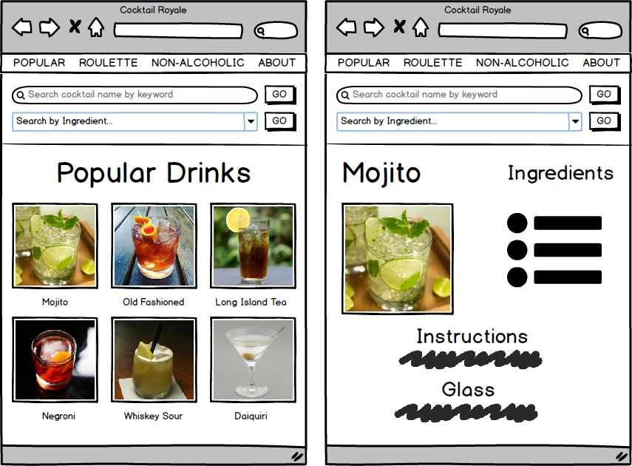

MVP

1. Search by Ingredient feature on all pages:

Ingredients auto-populated into the dropdown list from the API.

1. Popular Drinks listed on the homepage.
2. Cocktail Roulette feature randomly selects a cocktail for you.
3. Cocktail Detail Page:  
   Image, ingredients, instructions, glass it’s served in etc.
4. About page:

Info about developer.

Full Features List: Phase 1

* Search by keyword.
* Search by single ingredient.
* Non-alcoholic drinks list - clickable to cocktail detail pages.
* Most recently added drinks list - clickable to cocktail detail pages.
* Random ingredient list - clickable to its cocktail list page.

Full Features List: Phase 2

Back end:

* Login with Authentication
* Ability to add, edit, delete cocktails, ingredients, categories etc

Front-end:

* A robust search feature has multiple ingredient dropdowns which are populated only with available ingredients according to matches. This makes it impossible to select combined ingredients that don’t result in a match.
* Suggest a cocktail feature - allows users to suggest a cocktail and picture which the admin can add or discard.
* User login to allow the user to save favorites.